November 2019
MONDAY | TUESDAY | WEDNESDAY | THURSDAY | FRIDAY
During this month, preschool will be collecting canned food items (non-perishable) to donate to NCEON. | NCEON GOAL:  850 items  Thank you for your continued support to our preschool program. |  | Please label all sweaters & coats with your child’s name or initials.  Change out spare clothing in your child’s backpack with more seasonal clothing. | 1  Tuition.  Intro Thanksgiving Unit.  Color & cut Turkey. Discuss “What are we thankful for?”  Thanksgiving painting fun.  Reading Challenge due.  Begin donating food for NCEON.
4  Intro letter “Aa” and learn beginning sound.  Intro apple unit. Color words.  Sequencing fun.  Thanksgiving fun and activities.  Music.  Food drive for NCEON. | 5 | 6  Continue letter “Aa”.  Make applesauce. Your child may dress in colors red, yellow & green. Learn about Johnny Appleseed. Journal. Graphing fun.  Prepare for library field trip.  Reading Challenge due.  Food drive for NCEON. | 7 | 8  Linthicum Library Field Trip  Wear green school shirts.  All 4’s meet at the library for 10:00 am.  Please pick up your child at the library for 11:30am.
11  Continue letter “Aa”.  Counting & sequencing activity. Journal.  Review Library field trip.  What is a Veteran?  Music.  Food drive for NCEON. | 12 | 13  Review letter “Aa”.  Pattern activity.  Continue learning about the first Thanksgiving.  Food drive for NCEON.  Hardee’s Fundraiser Night  5:00 to 8:00 pm | 14 | 15  Intro letter “Tt” and learn  beginning sound.  Continue learning about the Pilgrims, Native American Indians and the Mayflower.  Thanksgiving activities & crafts.  Reading Challenge due.  Food drive for NCEON.
18  Continue letter “Tt”.  Journal writing.  Thanksgiving journal activity.  Thanksgiving crafts.  Music.  Food drive for NCEON. | 19 | 20  Thanksgiving Party.  Make Stone Soup. Bring ingredients at beginning of class (see bulletin board for sign-ups). Children may dress to represent Pilgrims or Native American Indians.  Last day for food drive for NCEON. | 21 | 22  Continue letter “Tt”.  Review & discuss “How we are thankful”.  Thanksgiving fun & activities.  Reading Challenge due.  Reading Challenge due.
25  Staff Day  No School | 26  No School | 27  No School | 28  Happy Thanksgiving!  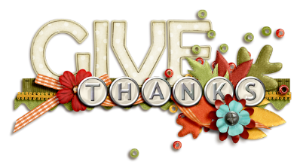  Be safe in your travels! | 29  No School

