November 2019

MONDAY | TUESDAY | WEDNESDAY | THURSDAY | FRIDAY
Please label all sweaters & coats with your child’s name or initials.  Change out spare clothing in your child’s backpack with more seasonal clothing. |  | During this month, preschool will be collecting canned food items (non-perishable) to donate to NCEON. |  | 1  NCEON GOAL:  850 items  Thank you for your continued support to our preschool program.
4 | 5  Tuition.  Intro letter “A”.  Intro Thanksgiving unit.  Discuss “What are we  thankful for?” Painting fun.  Begin Food Drive for NCEON. | 6  . | 7  Continue letter “A”.  Intro apple unit. Learn colors of apples. Your child may dress in colors red, yellow & green. Make applesauce. Make apple craft.  Reading Challenge due.  Food Drive for NCEON. | 8
11 | 12  Review letter “A”.  Journal activity.  Pattern fun.  Thanksgiving craft.  Food Drive for NCEON. | 13  Hardee’s Fundraiser Night  Nursery Road  5:00 to 8:00 pm | 14  Intro letter “T”.  Thanksgiving journal activity.  Counting fun.  Reading Challenge due.  Food Drive for NCEON. | 15
18 | 19  Review letter “T”.  Discuss Pilgrims & Native American Indians.  Thanksgiving crafts & activities.  Food Drive for NCEON. | 20 | 21  Thanksgiving Party.  Combined 3 year old classes.  All 3’s come 10:00 am to Noon.  Celebrate Thanksgiving with our preschool friends with a special feast. Children may dress to represent Pilgrims or Native American Indians. Reading Challenge due.  Last day for food drive for NCEON. | 22
25  Staff Day  No School | 26  No School | 27  No School | 28  Happy Thanksgiving!  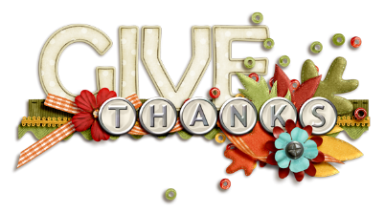  Be safe in your travels! | 29  No School

