September 2019

MONDAY | TUESDAY | WEDNESDAY | THURSDAY | FRIDAY
2  Labor Day  No School | 3  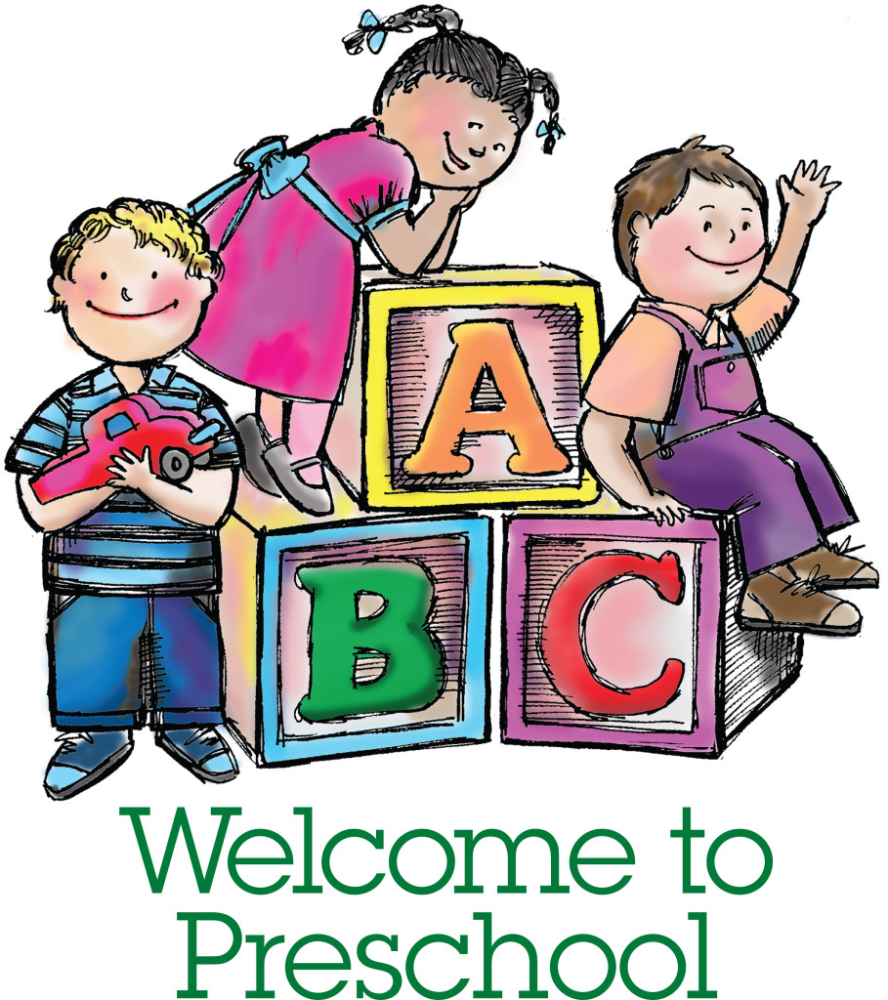 | 4  4’s First day of Preschool.  Getting to know FRIENDS, TEACHERS, SCHOOL & CHURCH. Begin Lord’s Prayer, Pledge of Allegiance. Free Play and Outside. Jesus loves me! | 5 | 6  Making new friends.  Making & learning school rules.  Painting fun.  Free Play and Outside fun.  God loves each of us the same.
9  Intro letter “Ff” & learn  beginning sound.  Letter “f” craft. Painting fun.  Learn about feelings.  Friendship stories.  Music. | 10 | 11  Last day to purchase BSO chaperone tickets.  Continue letter “Ff”. Chapel.  Journal writing.  Intro Five Senses. Playground.  Hardee’s Night  Nursery Road  5:00 to 8:00 pm | 12 | 13  Last day to purchase Disney On Ice tickets.  Review letter “Ff”.  Intro sense of “TOUCH”.  Touch & Feel box.  Explore church grounds to feel different textures. Fire Drill.  1st Reading Challenge due.
16  Intro letter “Ll” & learn  beginning sound.  Intro sense of “SIGHT”.  “Seeing” the magic of colors.  Leaf craft.  Cutting and counting fun.  Music. | 17 | 18  Continue letter “Ll”.  Journal writing.  Intro sense of “TASTE”.  (Sweet, Salty, Sour).  Graphing fun. | 19 | 20  Bring your lunch today!  Review letter “Ll”.  Letter “l” craft  Intro sense of “SMELL”.  “What’s that smell?” game.  Reading Challenge due.
23  Intro letter “Pp” & learn  beginning sound.  Intro sense of “HEARING”. Exploring sounds of musical instruments. Painting “p” craft.  Patterns. Music. | 24 | 25  Picture day. Individual & class photographs. Wear your favorite outfit. Please bring siblings to be photographed at beginning of class time.  Journal writing.  Review five senses.  Cutting activity. | 26 | 27  Pumpkin patch chaperone  money due. Last day to pay the required Activity fee and to return the Developmental Screening Questionnaires.  Continue letter “Pp”.  Painting. Counting activity.  Reading Challenge due.
30  No Preschool  (AA Co. Schools Closed) |  | .

