September 2019

MONDAY | TUESDAY | WEDNESDAY | THURSDAY | FRIDAY
2  Labor Day  No School | 3  3’s First day of Preschool  One hour only  3AM: 9:30 am to 10:30 am  3PM: 12:00 pm to 1:00 pm | 4  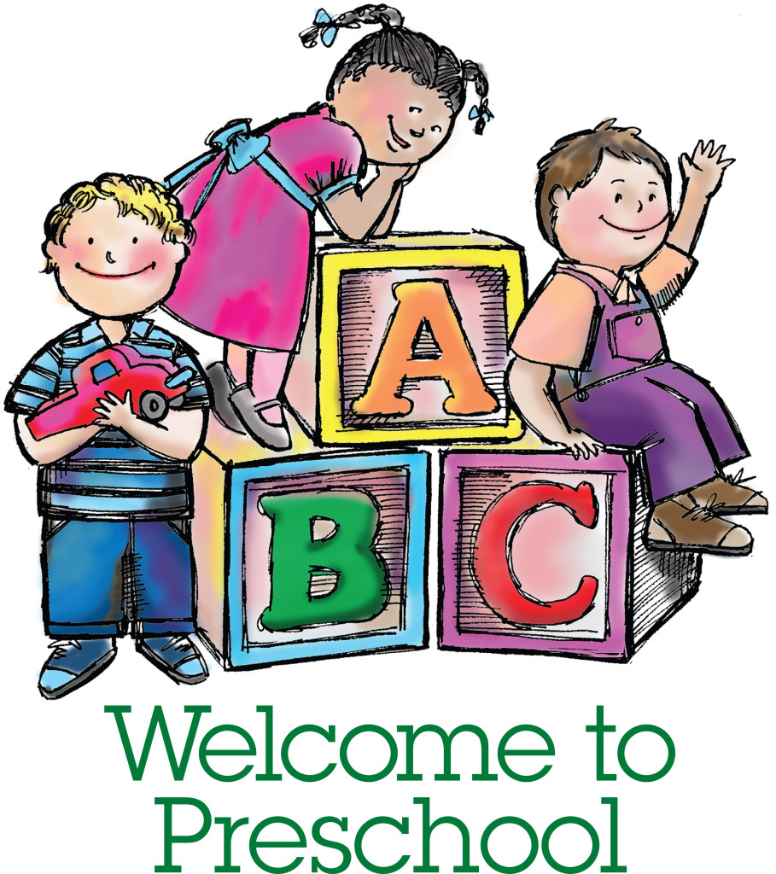 | 5  3’s Begin Normal Class Schedule.  3AM: 9:00 am to 11:00 am  3PM: 12:00 pm to 2:00 pm  Get to know teachers & friends. Jesus loves me! | 6
9 | 10  Intro letter “F”.  Intro Lord’s Prayer & Pledge of Allegiance.  Painting “f” craft.  Intro Five Senses. | 11  Hardee’s Night  Nursery Road  5:00 to 8:00 pm | 12  Review letter “F”.  Intro sense of “TOUCH”.  Take a nature walk & “touch” God’s beautiful creations.  Fire Drill.  1st Reading Challenge due. | 13  Last day to purchase  Disney on Ice  Tickets.
16 | 17  Intro letter “L”.  Intro sense of “SIGHT”.  Paint “L” craft. Discuss colors.  “Brown Bear, Brown Bear What Do You See?” | 18 | 19  Review letter “L”.  Intro sense of “SMELL”.  “What’s that smell?” game.  Reading Challenge due. | 20
23 | 24  Intro letter “P”.  Intro sense of “HEARING”.  “Listening” game.  Paint “P” craft.  Intro farm unit. | 25 | 26  Pumpkin Patch chaperone  money due.  Picture Day. Individual & class photographs. Wear your favorite outfit. Please bring siblings to be photographed at beginning of class time.  Review letter “P”. Intro sense of “TASTE”.  What tastes sweet? What tastes salty?  Review five senses. Reading Challenge. | 27  Last day to pay the  required Activity fee.  Last day to return the Developmental Screening Questionnaires.
30

